**База данных**

[СПРАВОЧНИК – СВЯЗИ В БД http://bseu.by/it/tohod/lekcii4_4.htm]

Создайте по своему варианту базу данных, используя предпочтительную платформу (MySQL / Microsoft SQL Server), на сервере баз данных, который вам предоставлен. В бд должно быть не менее 5 таблиц. Если в вашей предметной области указано меньше, необходимо придумать свои таблицы, которые соответствуют по логике предметной области.

Разработанная вами база данных должна быть в 3 НФ с обеспечение ссылочной целостности.

При разработке диаграммы обратите внимание на согласованную осмысленную схему именования, создайте необходимые первичные и внешние ключи, определите ограничения внешних ключей, отражающие характер предметной области.

ER - диаграмма должна быть представлена в формате удобном для просмотра и содержать таблицы, связи между ними, атрибуты и ключи (типами данных на данном этапе можно пренебречь) проведение анализа поставленной задачи и проектирования базы данных (ERD модели) с применением case-средств.

Создайте все необходимые сущности, определите отношения, создайте ограничения на связи между сущностями (при наличии всех связей), приведите базу данных к 3НФ (при наличии всех сущностей и связей).

Заказчик системы предоставил файлы с данными (с пометкой import в ресурсах) для переноса в новую систему. Заполните базу данных.

Выполните резервное копирование БД, сохраните полученные результаты.

К разработанной базе данных создайте словарь данных, представленный в таблице 1.

Таблица 1 - Словарь данных

|  |  |  |  |  |
| --- | --- | --- | --- | --- |
| **KEY** | **Имя поля** | **Тип данных / Размер** | **Необходимо?** | **Примечания** |
| PK | ID_Kategor | INTEGER | Y | Auto Increment |
|  | Name_Кat | NVARCHAR (100) | Y |  |
| FK ОTDEL | ID_Otdel | INTEGER | Y | On delete(update) cascade |

Напишите SQL-скрипт генерации таблиц БД. Использовать конструктор/генерацию по ER нельзя.

Создайте с помощью скрипта на сервере таблицы основных сущностей, атрибуты, отношения и необходимые ограничения.

В последующих заданиях вам возможно понадобится добавить какие-либо сущности в ходе работы над проектом.

**Отчёт**

Отчёт должен содержать следующее:

1. ER-модель бд;
2. Словарь данных;
3. Скрипт бд;
4. Скриншоты резервного копирования;
5. Скриншоты готовых таблиц с заполненными данными.

ER-модель бд:

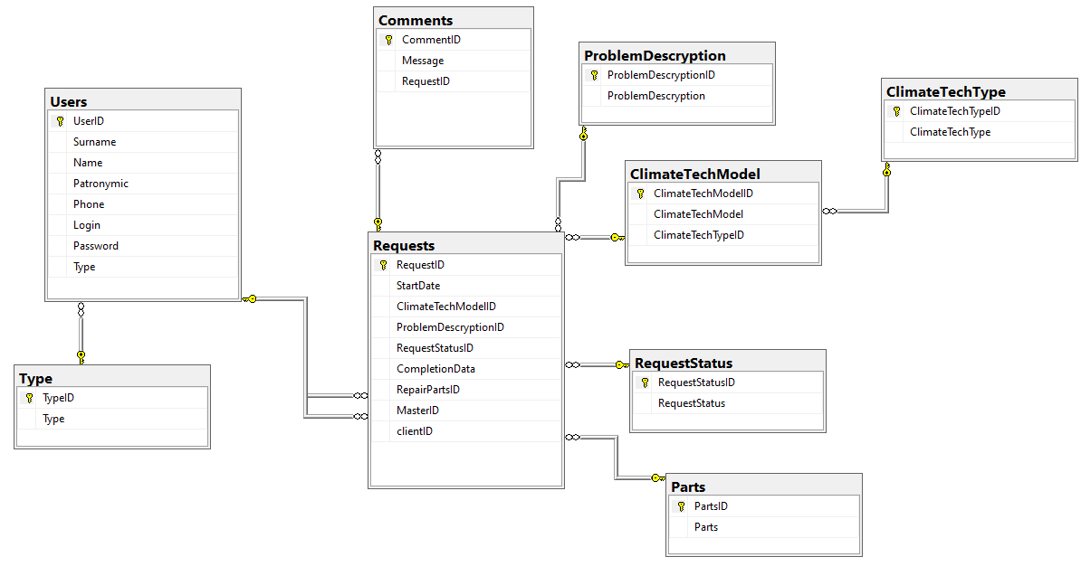

Словарь данных:

**Comment**

|  |  |  |  |  |
| --- | --- | --- | --- | --- |
| **KEY** | **Имя поля** | **Тип данных / Размер** | **Необходимо?** | **Примечания** |
| PK | CommentID | INTEGER | N | Auto Increment |
|  | Message | NVARCHAR (50) | Y |  |
| FK Requests | RequestID | INTEGER | N | On delete(update) cascade |

**Users**

|  |  |  |  |  |
| --- | --- | --- | --- | --- |
| **KEY** | **Имя поля** | **Тип данных / Размер** | **Необходимо?** | **Примечания** |
| PK | UserID | INTEGER | N | Auto Increment |
|  | Surname | nvarchar(20) | N |  |
|  | Name | nvarchar(20) | N |  |
|  | Patronymic | nvarchar(20) | N |  |
|  | Phone | char(16) | N |  |
|  | Login | nvarchar(10) | N |  |
|  | Password | nvarchar(10) | N |  |
| FK Type | Type | INTEGER | N | On delete(update) cascade |

**ClimateTechType**

|  |  |  |  |  |
| --- | --- | --- | --- | --- |
| **KEY** | **Имя поля** | **Тип данных / Размер** | **Необходимо?** | **Примечания** |
| PK | ClimateTechTypeID | INTEGER | N | Auto Increment |
|  | ClimateTechType | nvarchar(20) | N |  |

**ProblemDescryption**

|  |  |  |  |  |
| --- | --- | --- | --- | --- |
| **KEY** | **Имя поля** | **Тип данных / Размер** | **Необходимо?** | **Примечания** |
| PK | ProblemDescryptionID | INTEGER | N | Auto Increment |
|  | ProblemDescryption | nvarchar(20) | N |  |

**RequestStatus**

|  |  |  |  |  |
| --- | --- | --- | --- | --- |
| **KEY** | **Имя поля** | **Тип данных / Размер** | **Необходимо?** | **Примечания** |
| PK | RequestStatusID | INTEGER | N | Auto Increment |
|  | RequestStatus | nvarchar(20) | N |  |

**Request**

|  |  |  |  |  |
| --- | --- | --- | --- | --- |
| **KEY** | **Имя поля** | **Тип данных / Размер** | **Необходимо?** | **Примечания** |
| PK | RequestID | INTEGER | N | Auto Increment |
|  | StartDate | DATE | N |  |
| FK ClimateTechModel | ClimateTechModelID | INTEGER | N | On delete(update) cascade |
| FK ProblemDescryption | ProblemDescryptionID | INTEGER | N | On delete(update) cascade |
| FK RequestStatus | RequestStatusID | INTEGER | N | On delete(update) cascade |
|  | CompletionData | DATE | N |  |
| FK RepairParts | RepairPartsID | INTEGER | N | On delete(update) cascade |
| FK Users | MasterID | INTEGER | Y | On delete(update) cascade |
| FK Users | clientID | INTEGER | N | On delete(update) cascade |

**Type**

|  |  |  |  |  |
| --- | --- | --- | --- | --- |
| **KEY** | **Имя поля** | **Тип данных / Размер** | **Необходимо?** | **Примечания** |
| PK | TypeID | INTEGER | N | Auto Increment |
|  | Type | nvarchar(20) | N |  |

**Parts**

|  |  |  |  |  |
| --- | --- | --- | --- | --- |
| **KEY** | **Имя поля** | **Тип данных / Размер** | **Необходимо?** | **Примечания** |
| PK | PartsID | INTEGER | N | Auto Increment |
|  | Parts | nvarchar(20) | N |  |

**ClimateTechModel**

|  |  |  |  |  |
| --- | --- | --- | --- | --- |
| **KEY** | **Имя поля** | **Тип данных / Размер** | **Необходимо?** | **Примечания** |
| PK | ClimateTechModelID | INTEGER | N | Auto Increment |
|  | ClimateTechModel | NVARCHAR(100) | N |  |
| FK ClimateTechType | ClimateTechTypeID | INTEGER | N | On delete(update) cascade |

Скрипты Бд:

USE [master]

GO

/****** Object: Database [CherA] Script Date: 30.10.2024 13:29:39 ******/

CREATE DATABASE [CherA]

CONTAINMENT = NONE

ON PRIMARY

( NAME = N'CherA', FILENAME = N'D:\MSSQL14.SQLSERVER\MSSQL\DATA\CherA.mdf' , SIZE = 8192KB , MAXSIZE = UNLIMITED, FILEGROWTH = 65536KB )

LOG ON

( NAME = N'CherA_log', FILENAME = N'D:\MSSQL14.SQLSERVER\MSSQL\DATA\CherA_log.ldf' , SIZE = 8192KB , MAXSIZE = 2048GB , FILEGROWTH = 65536KB )

GO

ALTER DATABASE [CherA] SET COMPATIBILITY_LEVEL = 140

GO

IF (1 = FULLTEXTSERVICEPROPERTY('IsFullTextInstalled'))

begin

EXEC [CherA].[dbo].[sp_fulltext_database] @action = 'enable'

end

GO

ALTER DATABASE [CherA] SET ANSI_NULL_DEFAULT OFF

GO

ALTER DATABASE [CherA] SET ANSI_NULLS OFF

GO

ALTER DATABASE [CherA] SET ANSI_PADDING OFF

GO

ALTER DATABASE [CherA] SET ANSI_WARNINGS OFF

GO

ALTER DATABASE [CherA] SET ARITHABORT OFF

GO

ALTER DATABASE [CherA] SET AUTO_CLOSE ON

GO

ALTER DATABASE [CherA] SET AUTO_SHRINK OFF

GO

ALTER DATABASE [CherA] SET AUTO_UPDATE_STATISTICS ON

GO

ALTER DATABASE [CherA] SET CURSOR_CLOSE_ON_COMMIT OFF

GO

ALTER DATABASE [CherA] SET CURSOR_DEFAULT GLOBAL

GO

ALTER DATABASE [CherA] SET CONCAT_NULL_YIELDS_NULL OFF

GO

ALTER DATABASE [CherA] SET NUMERIC_ROUNDABORT OFF

GO

ALTER DATABASE [CherA] SET QUOTED_IDENTIFIER OFF

GO

ALTER DATABASE [CherA] SET RECURSIVE_TRIGGERS OFF

GO

ALTER DATABASE [CherA] SET ENABLE_BROKER

GO

ALTER DATABASE [CherA] SET AUTO_UPDATE_STATISTICS_ASYNC OFF

GO

ALTER DATABASE [CherA] SET DATE_CORRELATION_OPTIMIZATION OFF

GO

ALTER DATABASE [CherA] SET TRUSTWORTHY OFF

GO

ALTER DATABASE [CherA] SET ALLOW_SNAPSHOT_ISOLATION OFF

GO

ALTER DATABASE [CherA] SET PARAMETERIZATION SIMPLE

GO

ALTER DATABASE [CherA] SET READ_COMMITTED_SNAPSHOT OFF

GO

ALTER DATABASE [CherA] SET HONOR_BROKER_PRIORITY OFF

GO

ALTER DATABASE [CherA] SET RECOVERY SIMPLE

GO

ALTER DATABASE [CherA] SET MULTI_USER

GO

ALTER DATABASE [CherA] SET PAGE_VERIFY CHECKSUM

GO

ALTER DATABASE [CherA] SET DB_CHAINING OFF

GO

ALTER DATABASE [CherA] SET FILESTREAM( NON_TRANSACTED_ACCESS = OFF )

GO

ALTER DATABASE [CherA] SET TARGET_RECOVERY_TIME = 60 SECONDS

GO

ALTER DATABASE [CherA] SET DELAYED_DURABILITY = DISABLED

GO

ALTER DATABASE [CherA] SET QUERY_STORE = OFF

GO

USE [CherA]

GO

/****** Object: Table [dbo].[ClimateTechModel] Script Date: 30.10.2024 13:29:39 ******/

SET ANSI_NULLS ON

GO

SET QUOTED_IDENTIFIER ON

GO

CREATE TABLE [dbo].[ClimateTechModel](

[ClimateTechModelID] [int] IDENTITY(1,1) NOT NULL,

[ClimateTechModel] [nvarchar](100) NOT NULL,

[ClimateTechTypeID] [int] NULL,

CONSTRAINT [PK__ClimateT__D5C9E5AB046F7906] PRIMARY KEY CLUSTERED

(

[ClimateTechModelID] ASC

)WITH (PAD_INDEX = OFF, STATISTICS_NORECOMPUTE = OFF, IGNORE_DUP_KEY = OFF, ALLOW_ROW_LOCKS = ON, ALLOW_PAGE_LOCKS = ON) ON [PRIMARY]

) ON [PRIMARY]

GO

/****** Object: Table [dbo].[ClimateTechType] Script Date: 30.10.2024 13:29:39 ******/

SET ANSI_NULLS ON

GO

SET QUOTED_IDENTIFIER ON

GO

CREATE TABLE [dbo].[ClimateTechType](

[ClimateTechTypeID] [int] IDENTITY(1,1) NOT NULL,

[ClimateTechType] [nvarchar](20) NOT NULL,

CONSTRAINT [PK__ClimateT__F46AD04F832C3948] PRIMARY KEY CLUSTERED

(

[ClimateTechTypeID] ASC

)WITH (PAD_INDEX = OFF, STATISTICS_NORECOMPUTE = OFF, IGNORE_DUP_KEY = OFF, ALLOW_ROW_LOCKS = ON, ALLOW_PAGE_LOCKS = ON) ON [PRIMARY]

) ON [PRIMARY]

GO

/****** Object: Table [dbo].[Comments] Script Date: 30.10.2024 13:29:39 ******/

SET ANSI_NULLS ON

GO

SET QUOTED_IDENTIFIER ON

GO

CREATE TABLE [dbo].[Comments](

[CommentID] [int] IDENTITY(1,1) NOT NULL,

[Message] [nvarchar](50) NULL,

[RequestID] [int] NULL,

CONSTRAINT [PK__Comments__C3B4DFAA4A4409DB] PRIMARY KEY CLUSTERED

(

[CommentID] ASC

)WITH (PAD_INDEX = OFF, STATISTICS_NORECOMPUTE = OFF, IGNORE_DUP_KEY = OFF, ALLOW_ROW_LOCKS = ON, ALLOW_PAGE_LOCKS = ON) ON [PRIMARY]

) ON [PRIMARY]

GO

/****** Object: Table [dbo].[Parts] Script Date: 30.10.2024 13:29:39 ******/

SET ANSI_NULLS ON

GO

SET QUOTED_IDENTIFIER ON

GO

CREATE TABLE [dbo].[Parts](

[PartsID] [int] IDENTITY(1,1) NOT NULL,

[Parts] [nvarchar](20) NOT NULL,

CONSTRAINT [PK__Parts__1038D962F854F176] PRIMARY KEY CLUSTERED

(

[PartsID] ASC

)WITH (PAD_INDEX = OFF, STATISTICS_NORECOMPUTE = OFF, IGNORE_DUP_KEY = OFF, ALLOW_ROW_LOCKS = ON, ALLOW_PAGE_LOCKS = ON) ON [PRIMARY]

) ON [PRIMARY]

GO

/****** Object: Table [dbo].[ProblemDescryption] Script Date: 30.10.2024 13:29:39 ******/

SET ANSI_NULLS ON

GO

SET QUOTED_IDENTIFIER ON

GO

CREATE TABLE [dbo].[ProblemDescryption](

[ProblemDescryptionID] [int] IDENTITY(1,1) NOT NULL,

[ProblemDescryption] [nvarchar](100) NOT NULL,

CONSTRAINT [PK__ProblemD__1C8980F399DFB122] PRIMARY KEY CLUSTERED

(

[ProblemDescryptionID] ASC

)WITH (PAD_INDEX = OFF, STATISTICS_NORECOMPUTE = OFF, IGNORE_DUP_KEY = OFF, ALLOW_ROW_LOCKS = ON, ALLOW_PAGE_LOCKS = ON) ON [PRIMARY]

) ON [PRIMARY]

GO

/****** Object: Table [dbo].[Requests] Script Date: 30.10.2024 13:29:39 ******/

SET ANSI_NULLS ON

GO

SET QUOTED_IDENTIFIER ON

GO

CREATE TABLE [dbo].[Requests](

[RequestID] [int] IDENTITY(1,1) NOT NULL,

[StartDate] [date] NOT NULL,

[ClimateTechModelID] [int] NOT NULL,

[ProblemDescryptionID] [int] NOT NULL,

[RequestStatusID] [int] NOT NULL,

[CompletionData] [date] NULL,

[RepairPartsID] [int] NULL,

[MasterID] [int] NULL,

[clientID] [int] NOT NULL,

CONSTRAINT [PK__Requests__33A8519A6FF42F99] PRIMARY KEY CLUSTERED

(

[RequestID] ASC

)WITH (PAD_INDEX = OFF, STATISTICS_NORECOMPUTE = OFF, IGNORE_DUP_KEY = OFF, ALLOW_ROW_LOCKS = ON, ALLOW_PAGE_LOCKS = ON) ON [PRIMARY]

) ON [PRIMARY]

GO

/****** Object: Table [dbo].[RequestStatus] Script Date: 30.10.2024 13:29:39 ******/

SET ANSI_NULLS ON

GO

SET QUOTED_IDENTIFIER ON

GO

CREATE TABLE [dbo].[RequestStatus](

[RequestStatusID] [int] IDENTITY(1,1) NOT NULL,

[RequestStatus] [nvarchar](20) NOT NULL,

CONSTRAINT [PK__RequestS__7094B7BB88C0F765] PRIMARY KEY CLUSTERED

(

[RequestStatusID] ASC

)WITH (PAD_INDEX = OFF, STATISTICS_NORECOMPUTE = OFF, IGNORE_DUP_KEY = OFF, ALLOW_ROW_LOCKS = ON, ALLOW_PAGE_LOCKS = ON) ON [PRIMARY]

) ON [PRIMARY]

GO

/****** Object: Table [dbo].[Type] Script Date: 30.10.2024 13:29:39 ******/

SET ANSI_NULLS ON

GO

SET QUOTED_IDENTIFIER ON

GO

CREATE TABLE [dbo].[Type](

[TypeID] [int] IDENTITY(1,1) NOT NULL,

[Type] [nvarchar](20) NOT NULL,

CONSTRAINT [PK__Type__516F039533E09026] PRIMARY KEY CLUSTERED

(

[TypeID] ASC

)WITH (PAD_INDEX = OFF, STATISTICS_NORECOMPUTE = OFF, IGNORE_DUP_KEY = OFF, ALLOW_ROW_LOCKS = ON, ALLOW_PAGE_LOCKS = ON) ON [PRIMARY]

) ON [PRIMARY]

GO

/****** Object: Table [dbo].[Users] Script Date: 30.10.2024 13:29:39 ******/

SET ANSI_NULLS ON

GO

SET QUOTED_IDENTIFIER ON

GO

CREATE TABLE [dbo].[Users](

[UserID] [int] IDENTITY(1,1) NOT NULL,

[Surname] [nvarchar](20) NOT NULL,

[Name] [nvarchar](20) NOT NULL,

[Patronymic] [nvarchar](20) NOT NULL,

[Phone] [char](16) NOT NULL,

[Login] [nvarchar](10) NOT NULL,

[Password] [nvarchar](10) NOT NULL,

[Type] [int] NOT NULL,

CONSTRAINT [PK__Users__1788CCACB251C017] PRIMARY KEY CLUSTERED

(

[UserID] ASC

)WITH (PAD_INDEX = OFF, STATISTICS_NORECOMPUTE = OFF, IGNORE_DUP_KEY = OFF, ALLOW_ROW_LOCKS = ON, ALLOW_PAGE_LOCKS = ON) ON [PRIMARY]

) ON [PRIMARY]

GO

ALTER TABLE [dbo].[ClimateTechModel] WITH CHECK ADD CONSTRAINT [FK_ClimateTechModel_ClimateTechType] FOREIGN KEY([ClimateTechTypeID])

REFERENCES [dbo].[ClimateTechType] ([ClimateTechTypeID])

ON UPDATE CASCADE

ON DELETE CASCADE

GO

ALTER TABLE [dbo].[ClimateTechModel] CHECK CONSTRAINT [FK_ClimateTechModel_ClimateTechType]

GO

ALTER TABLE [dbo].[Comments] WITH CHECK ADD CONSTRAINT [FK_Comments_Requests] FOREIGN KEY([RequestID])

REFERENCES [dbo].[Requests] ([RequestID])

ON UPDATE CASCADE

ON DELETE CASCADE

GO

ALTER TABLE [dbo].[Comments] CHECK CONSTRAINT [FK_Comments_Requests]

GO

ALTER TABLE [dbo].[Requests] WITH CHECK ADD CONSTRAINT [FK_Requests_ClimateTechModel] FOREIGN KEY([ClimateTechModelID])

REFERENCES [dbo].[ClimateTechModel] ([ClimateTechModelID])

ON UPDATE CASCADE

ON DELETE CASCADE

GO

ALTER TABLE [dbo].[Requests] CHECK CONSTRAINT [FK_Requests_ClimateTechModel]

GO

ALTER TABLE [dbo].[Requests] WITH CHECK ADD CONSTRAINT [FK_Requests_Parts] FOREIGN KEY([RepairPartsID])

REFERENCES [dbo].[Parts] ([PartsID])

ON UPDATE CASCADE

ON DELETE CASCADE

GO

ALTER TABLE [dbo].[Requests] CHECK CONSTRAINT [FK_Requests_Parts]

GO

ALTER TABLE [dbo].[Requests] WITH CHECK ADD CONSTRAINT [FK_Requests_ProblemDescryption] FOREIGN KEY([ProblemDescryptionID])

REFERENCES [dbo].[ProblemDescryption] ([ProblemDescryptionID])

ON UPDATE CASCADE

ON DELETE CASCADE

GO

ALTER TABLE [dbo].[Requests] CHECK CONSTRAINT [FK_Requests_ProblemDescryption]

GO

ALTER TABLE [dbo].[Requests] WITH CHECK ADD CONSTRAINT [FK_Requests_RequestStatus] FOREIGN KEY([RequestStatusID])

REFERENCES [dbo].[RequestStatus] ([RequestStatusID])

ON UPDATE CASCADE

ON DELETE CASCADE

GO

ALTER TABLE [dbo].[Requests] CHECK CONSTRAINT [FK_Requests_RequestStatus]

GO

ALTER TABLE [dbo].[Requests] WITH CHECK ADD CONSTRAINT [FK_Requests_Users] FOREIGN KEY([MasterID])

REFERENCES [dbo].[Users] ([UserID])

ON UPDATE CASCADE

ON DELETE CASCADE

GO

ALTER TABLE [dbo].[Requests] CHECK CONSTRAINT [FK_Requests_Users]

GO

ALTER TABLE [dbo].[Requests] WITH CHECK ADD CONSTRAINT [FK_Requests_Users1] FOREIGN KEY([clientID])

REFERENCES [dbo].[Users] ([UserID])

GO

ALTER TABLE [dbo].[Requests] CHECK CONSTRAINT [FK_Requests_Users1]

GO

ALTER TABLE [dbo].[Users] WITH CHECK ADD CONSTRAINT [FK_Users_Type] FOREIGN KEY([Type])

REFERENCES [dbo].[Type] ([TypeID])

ON UPDATE CASCADE

ON DELETE CASCADE

GO

ALTER TABLE [dbo].[Users] CHECK CONSTRAINT [FK_Users_Type]

GO

ALTER TABLE [dbo].[Users] WITH CHECK ADD CONSTRAINT [CK__Users__Phone__05D8E0BE] CHECK (([Phone] like '8 [0-9][0-9][0-9]-[0-9][0-9][0-9]-[0-9][0-9]-[0-9][0-9]'))

GO

ALTER TABLE [dbo].[Users] CHECK CONSTRAINT [CK__Users__Phone__05D8E0BE]

GO

USE [master]

GO

ALTER DATABASE [CherA] SET READ_WRITE

GO

Резервное копирование:

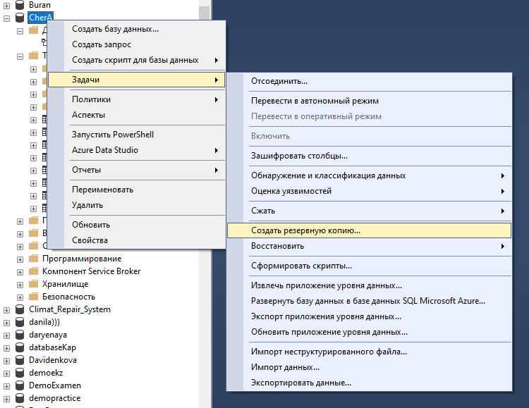

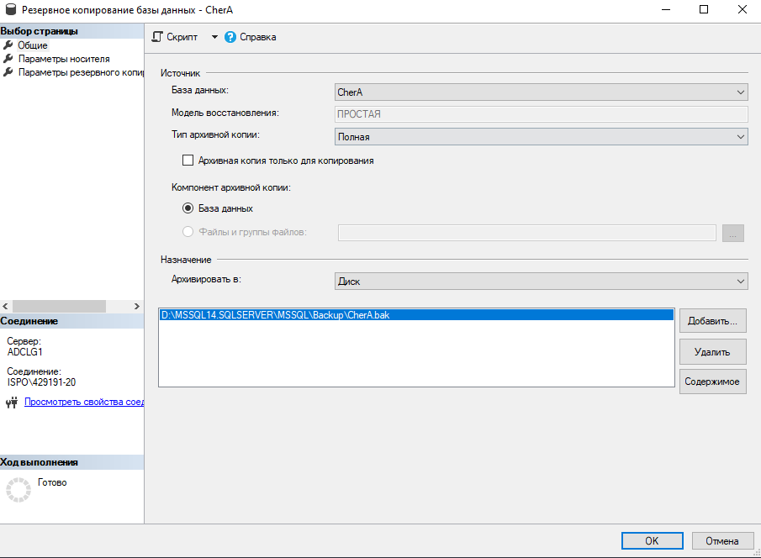

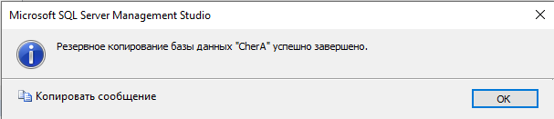

Скриншоты готовых таблиц с заполненными данными:

